**The following technologies are required to complete training**

* **Git: We'll use Git as a version control tool during this program.** Not only will you use Git to track changes to your projects, but you will also use it to collaborate with your trainer and with your fellow associates.
* **Java SE Development Kit 17 (JDK): We will use Java 17 as our primary language throughout training.** This software development kit will provide the compiler and runtime environment we need to develop Java applications quickly and efficiently.
* **IntelliJ IDEA**: I will be using IntelliJ IDEA as our *integrated development environment* (IDE). Though you don't need an IDE to write code, an IDE provides several features that make rapid development (e.g., quickly writing and refactoring code) easier. Yes, you can use whatever IDE you prefer, but I’ll have a harder time helping you debug. I have used Spring Tools & Eclipse for Java development, but IntelliJ has proved more user friendly to me.
* **DBeaver:** DBeaver is an open-source database tool that is compatible with several external data sources. We'll use DBeaver in order to modify our databases (which will be hosted on AWS) and persist data using a simple user interface provided to us by the tool.
* **Visual Studio Code:** Visual Studio Code is a text editor that makes viewing and modifying code simple. Do not confuse this tool with an integrated development environment as it is not equipped with all the development tools you typically find in an IDE. We will be leveraging this tool for much of our front-end development.
* **Postman:** Postman is what we’ll use to send information back and forth to your Java servers without having to build a webpage. Great for testing and debugging! It’s used for testing RESTful APIs, which we’ll learn about. It can be used to quickly test individual endpoints to make sure they work as intended.

**\*\*\*Some of these screenshots are older, so the versioning will be different. Don’t worry about it and download the latest versions you find on the download links. Though I recommend sticking with known modern stable(!) Java versions (11, 14, or 17 should be fine choices. It would be best to stick with Java 17 as stated above.)**

### **Step 1: Install Git**

* Navigate to [Git's Website](https://git-scm.com/download) and **click the latest download for Windows**. (For those using a different OS click the appropriate OS and look for the most recent stable release.)

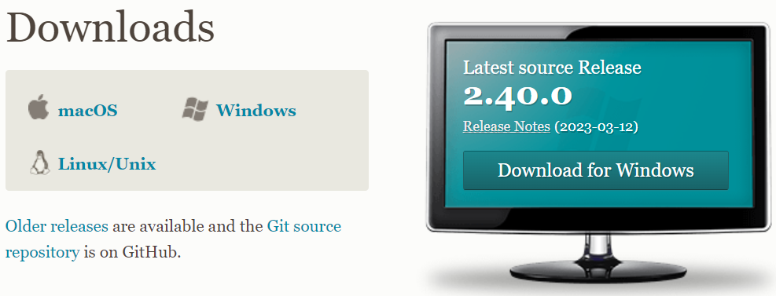

* Click yes to any security/firewall popup asking if you are sure you want to download the file.
* The install file will begin downloading; most browsers will show the file that has just been downloaded, click that file when it completes. 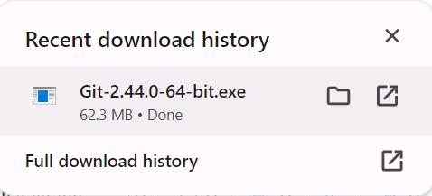
* If you can’t click the downloaded file, look for it in your downloads folder.

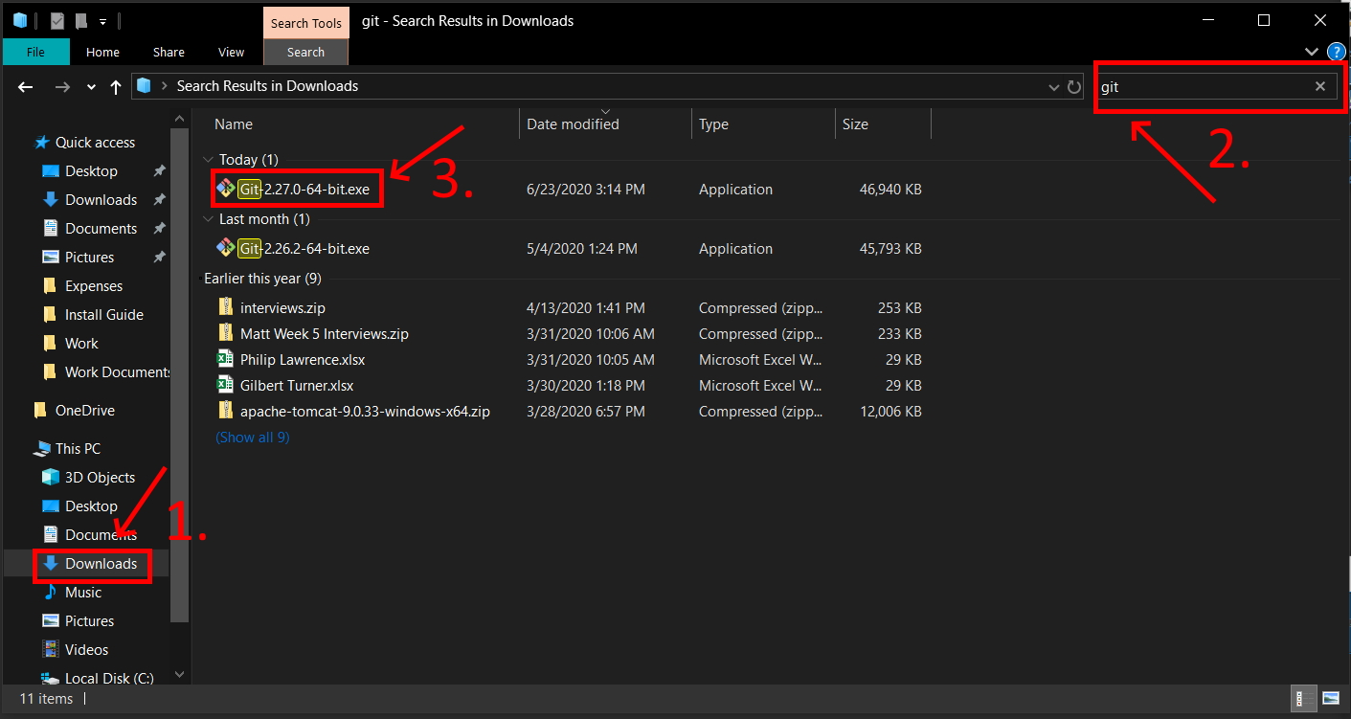

* Click yes to any security pop-ups asking you if you want to allow the installer to make changes to your computer.
* The install wizard will open to guide you through the process of installing Git. Accept the license agreement and click "Next.

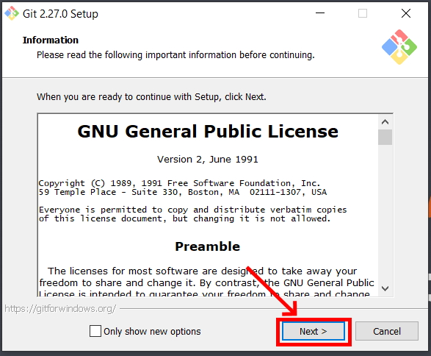

* If you get this option, accept the default installation path by clicking "Next."

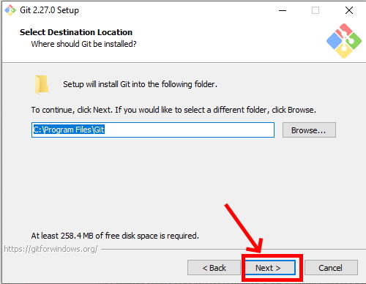

* Select your components. It is recommended to add a desktop icon. Leave the other boxes in their default setting. Click "Next."

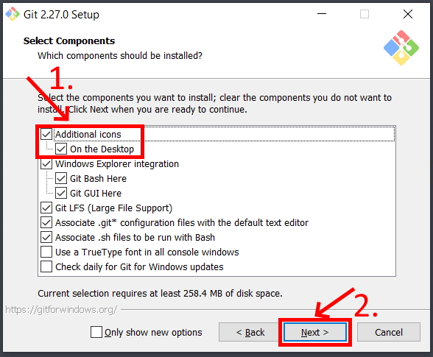

* **Leave the rest of the set up as the default configuration clicking Next until you can click Install.** This will run the actual install process.
* After installation, you will get a final window giving you the options to launch Git Bash and view the Readme notes. Open Git Bash and deselect the view Readme notes. Click "Next."  
  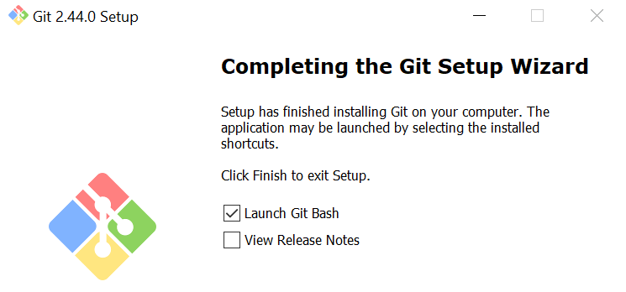
* When Git Bash opens, type "git --version" and hit Enter. If it returns the version of Git, you installed it correctly.

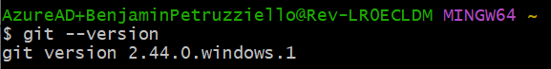

**Step 2: Install Java**

* Navigate in your web browser to Oracle’s [Java 17 Download Page](https://www.oracle.com/java/technologies/downloads/#java17)
* NOTE: If you are experiencing errors when trying to load the webpage try another browser. If you still are having trouble, try again later.
* In the top right of the website click "View Accounts" and then "Create an Account." (If you already have an Oracle account you can skip ahead)

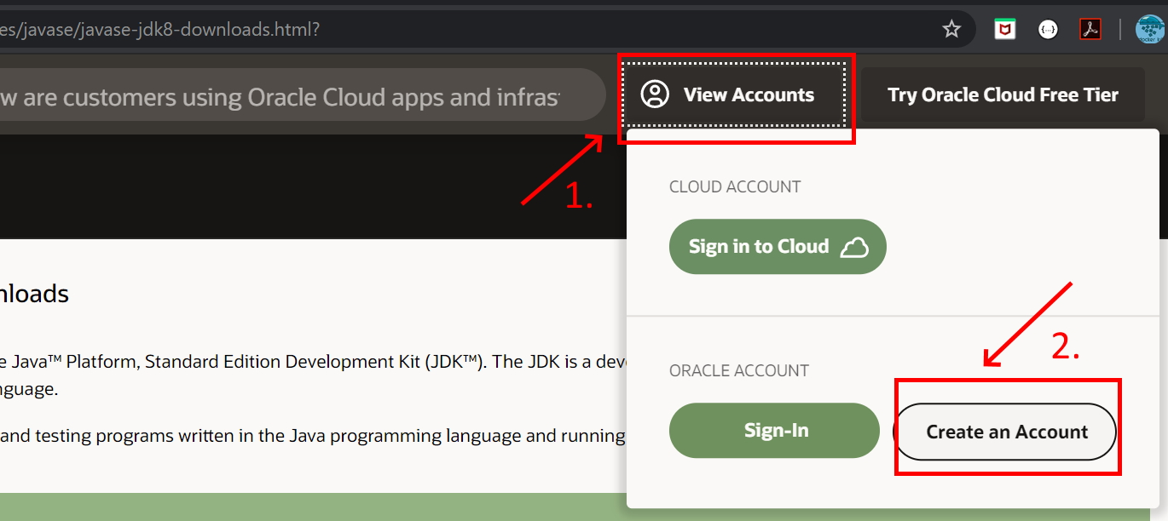

* Fill in the form with your information (you may type "none" or “Revature” for Company Name. Doesn’t matter.) and then click the "Create Account" button.

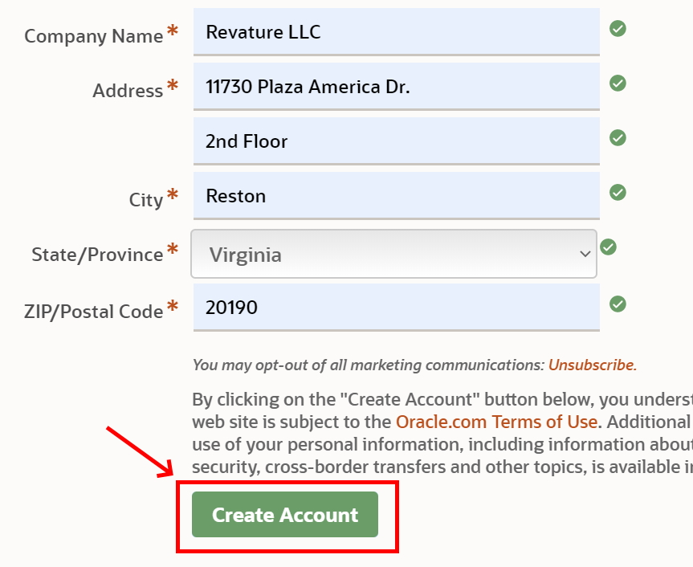

* Check your email account for a new message from Oracle. (This may take a few minutes.) When you receive the email, open it and click the "Verify Email Address" button inside. This should direct you to a successful screen.

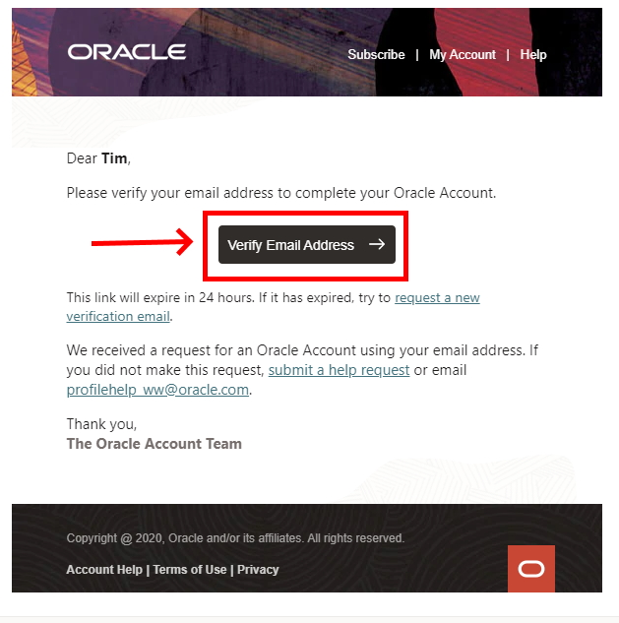

* Return to [The Java 17 Download Page](https://www.oracle.com/java/technologies/downloads/#java17). Scroll to find the appropriate JDK for your Operating System and Architecture. (Windows 10 will be Windows x64 as shown below. MacOS will be the DMG installer). Click to download.

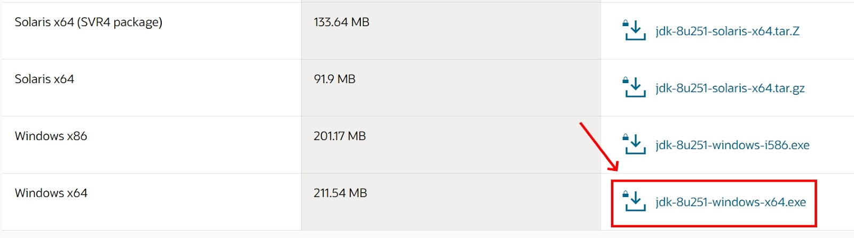

* A popup will ask you to review the license before continuing. Read the whole thing (or not), click the check box, and then the download button.

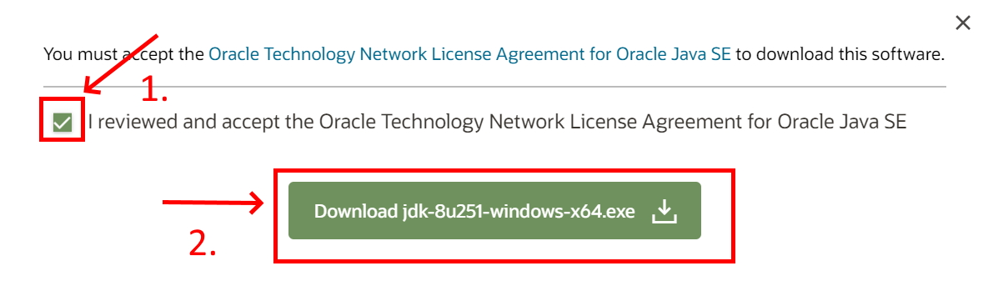

* If you are not signed in, a popup will appear asking you to do so. Enter your sign in information (your email is your username) and submit. The download should then begin.

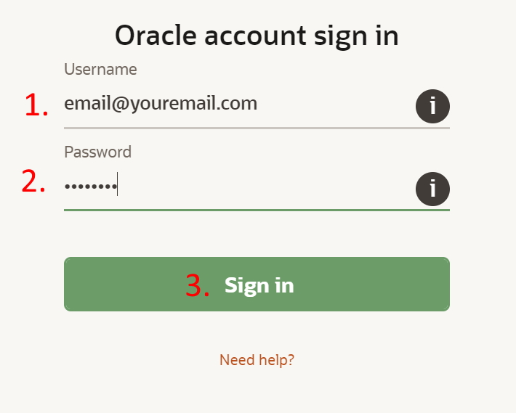

* Once the download is complete, click the file that downloads in your browser to open it. If you do not see the file in your browser, find it in your downloads folder.

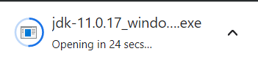

* If you could not open the JDK installer from your browser, open your file explorer. The exe in your downloads folder should look like this. Click it!



* Allow it to make changes to your computer, and hit next to get started.

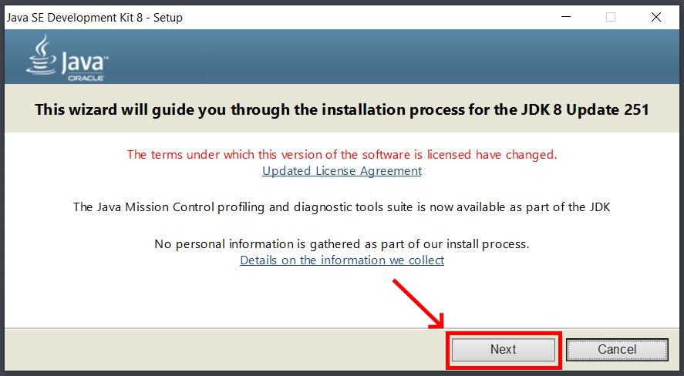

* The installer will continue, and you should accept the default setup. IMPORTANT: Note the file path for the installation directory! You WILL need this later. Click "Next."
* The install will begin extracting files. When Java finishes installing, you can click "Close."
* Use your system search tool (next to the windows button) to look for "Edit the system environment variables" in the control panel. Be sure that you open the SYSTEM environment not the ones just for your account.
* Click the "Environment Variables" button in the window that opens.

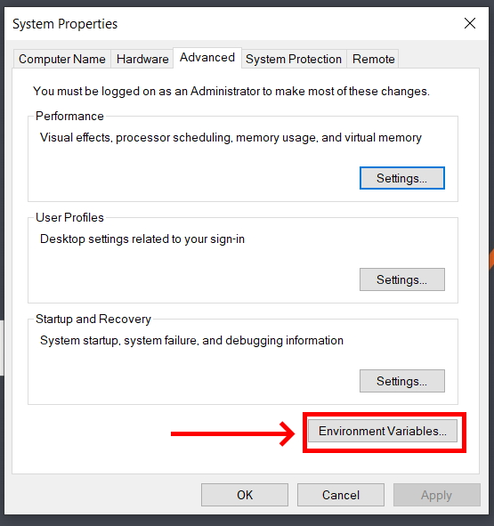

* Under "**System Variables**" click the "New" button.

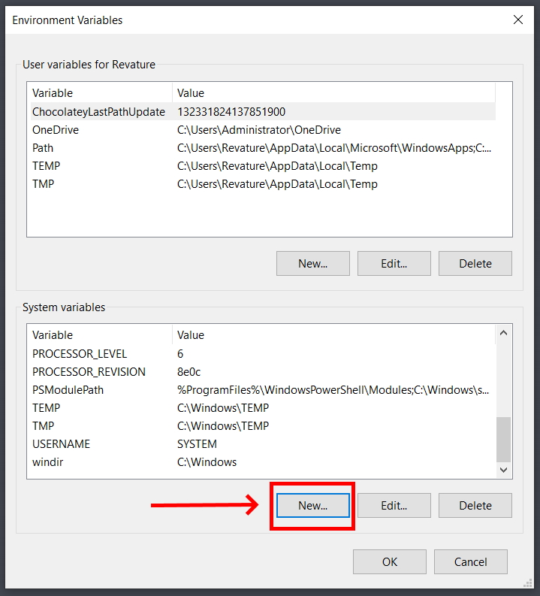

* Name the new variable "JAVA_HOME" and give it the value of the directory where your JDK was installed to. If you are unsure of your directory path, you can go to C:\Program Files\Java in your file explorer then click on the JDK folder to open it. You can then copy the path from the navigation bar at the top of the file explorer.

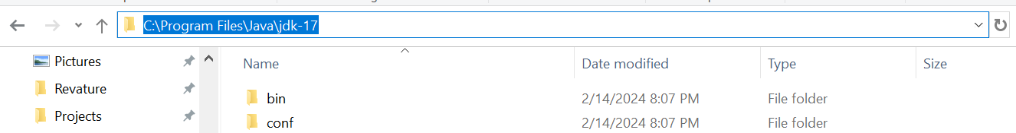

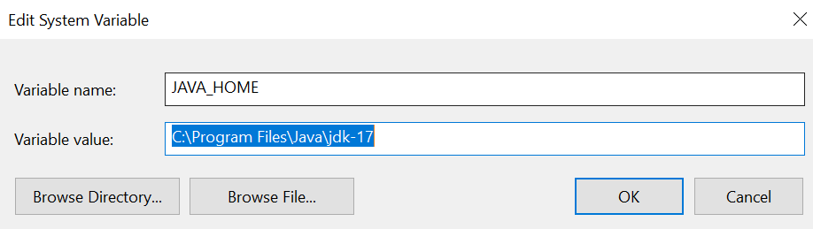

* Next, in your system variables, select the "Path" variable and click "Edit."

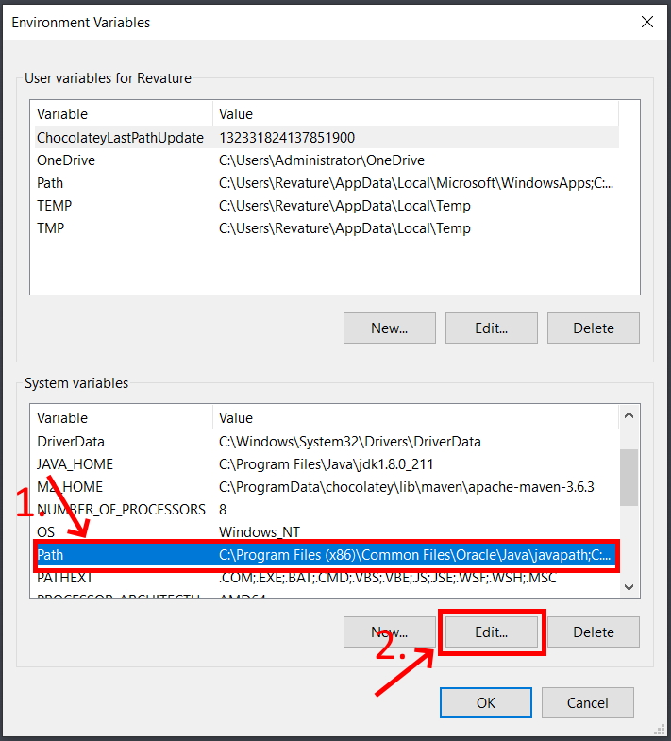

* Click "New" to create a new line. Add the path to the JDK bin folder in this line, it will be the same path you used for JAVA_HOME, with a "\bin" at the end.

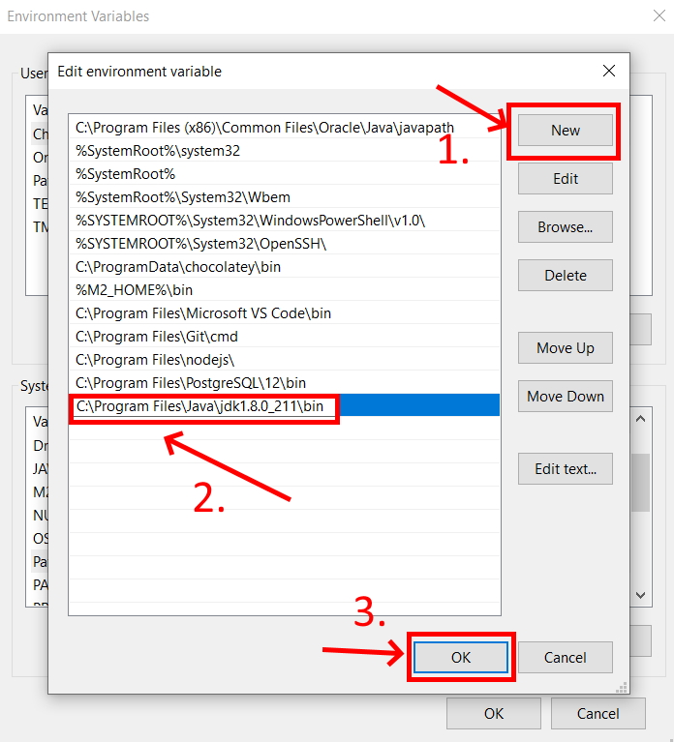

* Click "OK" to close the Environment Variables window.
* Open Git Bash, type "java -version" and hit Enter. If the JDK is installed correctly you should see Java with the version you downloaded.

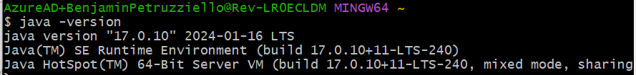

### **Step 3: Install IntelliJ IDEA**

* Click on this link to install **IntelliJ IDEA:** [**https://www.jetbrains.com/idea/download/#section=windows**](https://www.jetbrains.com/idea/download/#section=windows)
* **Make sure to choose the download for whatever OS (windows/mac etc.) you’re using.**
  + **Make sure to choose the COMMUNITY EDITION as it is free.**

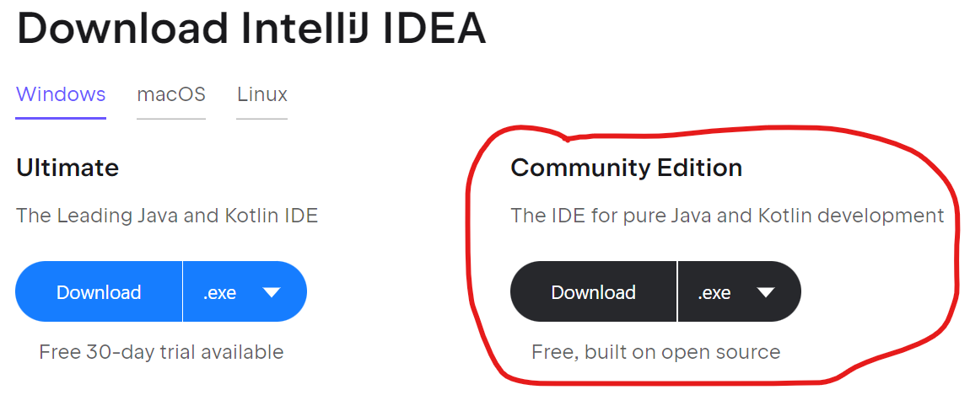

* The installer will open. Note the installation location. Change it if you’d like.
* If you want even easier access, check the box to create a desktop shortcut. **Also, check the box to create a Java association** (this lets you right click and open applications in IntelliJ directly from your file explorer).

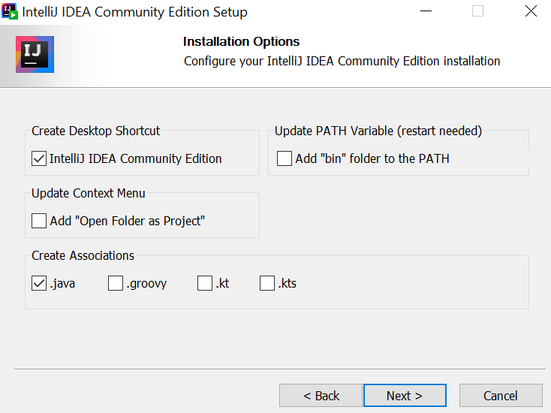

* Hit “next” through everything else until you can hit “install” ... It will install.

### **Step 4: Install DBeaver (and postgreSQL)**

* PostgreSQL is the SQL dialect (the “flavor” of SQL) we’ll be using. DBeaver is essentially the IDE (Integrated Development Environment) for our SQL, which we’ll use to create and manage our databases.
* I suggest you download PostgreSQL first. It’s a lot quicker than DBeaver setup and you’ll need to have a SQL dialect downloaded before you can even use DBeaver.

<https://www.postgresql.org/download/> **<-POSTGRESQL DOWNLOAD**

^^Follow this link to download PostgreSQL. The installer is very short and intuitive. The latest version should be fine. **MAKE SURE TO REMEMBER THE PASSWORD YOU SET**! It’s a pain to reset. Pro tip: Just make it “password”.

* When it asks what stack builder you want to use, select the one you already have installed and hit next.
* **I’m going to reiterate this in scary bold red characters… PLEASE just make your postgresql password “password”.** If you don’t make your password “password” and fail to remember the password you chose, you’ll have to go through the process of deleting and reinstalling postgres and you’ll feel real silly. It’ll inevitably happen to some but hopefully this wall of text minimizes those instances :)
* Now, in order to install DBeaver, please click this link to visit [DBeaver's official website](https://dbeaver.io/download/). Once you get to the website, you'll notice that there are two options: Community Edition and Enterprise Edition. Please select the **Community Edition** as it is free.
* You will find the installers for the Community Edition if you scroll down the page. They should be located directly beneath the box which says "Community Edition X.X.X". As with all other software listed here, please make sure that you choose the correct installer for your system.

Once you've clicked on the installer that is compatible with your system, you'll be prompted to save the file. Save it and note where you've saved it on your machine. These files are usually stored in your computer's "Downloads" folder by default.

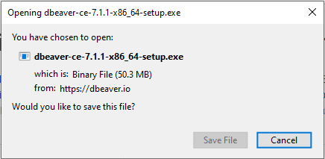

If the installer doesn’t open automatically, navigate to the folder where the installer is stored. For this example, we've downloaded the file to the "Downloads" folder.

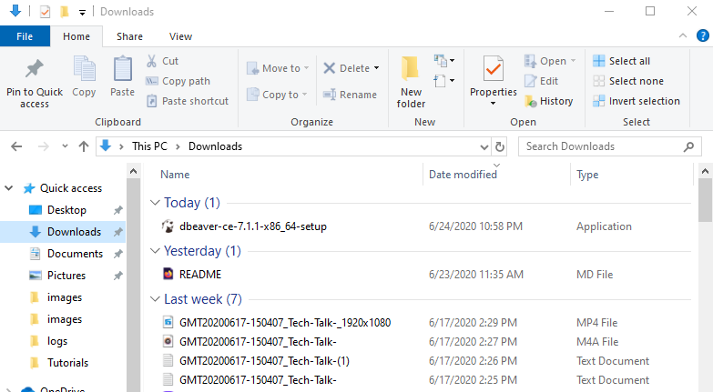

Double click the installer. Once you've done so, the installer will be launched. The installer should take you through the process of setting up DBeaver. You'll be asked, for instance, to select a language of choice and review license terms before you install the software.

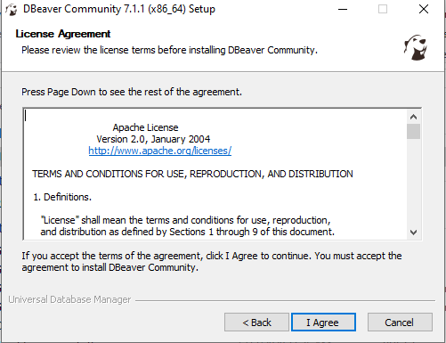

When you arrive at the portion of the setup which is titled "Choose Components", please select "DBeaver Community", “Include Java”, and "Associate .SQL files".

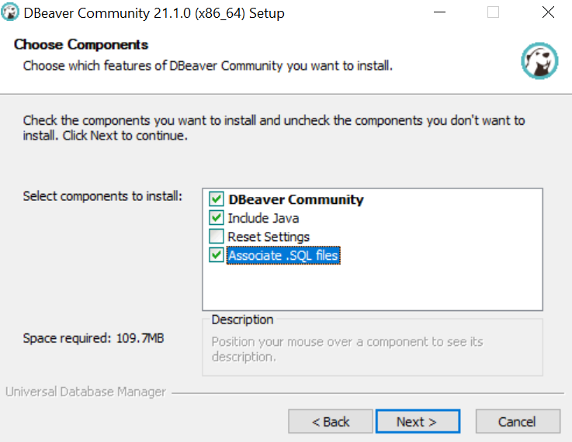

If your installation was successful, you should now be able to search for and find "DBeaver" on your machine.

**Step 5: Install Postman**  
  
**We use Postman to send and receive information from our back end (java) without having to build out an entire webpage front end. To download Postman, please visit** [Postman's official website](https://www.postman.com/downloads/).

Once you've navigated to the site, you should see the following:

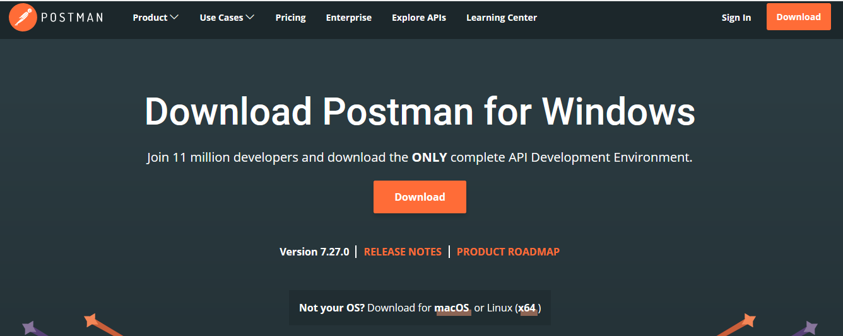

Note that the default download is for Windows. If you wish to download Postman for Mac or Linux, you should click on one of the links highlighted in the small box beneath the version number and "RELEASE NOTES" link. You can see these links at the bottom of the image provided above for reference.

You should now click the "Download" button, at which point you'll be prompted to select either Windows 32-bit or Windows 64-bit (assuming you're downloading Postman for Windows). Choose the option which is compatible with your system **(probably 64 bit)**. You'll then be prompted to save the file.

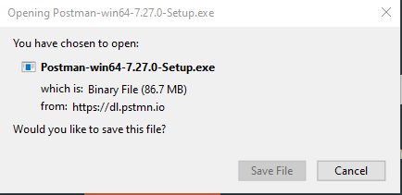

Once you've saved the file, open your "Downloads" folder and double click the newly downloaded installer.

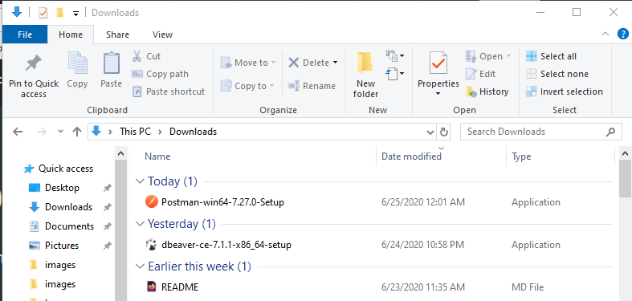

Upon double clicking the executable, the installer will be launched and the program will be installed. In order to verify that it has been installed correctly, you can search for "Postman" on your machine.

Note that you'll likely have to sign up for an account to use the application. Please do so as signing up for an account is completely free.

### **Step 6: Install Visual Studio Code**

To download Visual Studio Code, please visit [Visual Studio Code's official website](https://code.visualstudio.com/download).

Once you've navigated to the website, you should see the following:

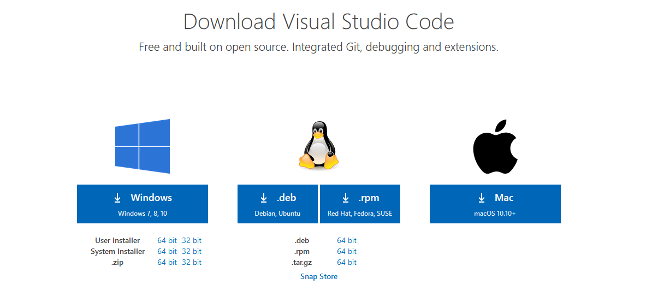

Choose the installer that is compatible with your system. Once you've clicked the installer of your choice, you'll be prompted to save the file. Do so.

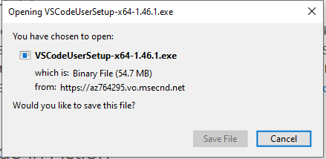

Once you've saved the installer, it should be located in your "Downloads" folder.

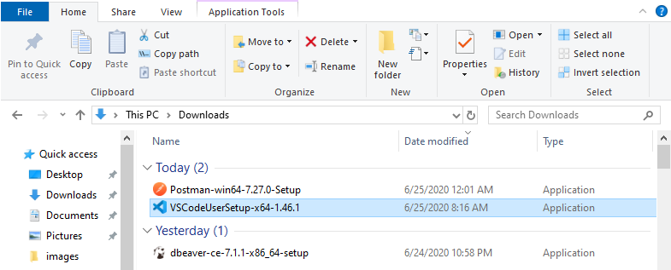

Double click the installer. Once you've done so, the installer should be launched. Accept the license agreement and proceed until you reach a menu titled "Select Additional Tasks". Once you've arrived here, be sure to check all of the boxes that are checked in the image below!

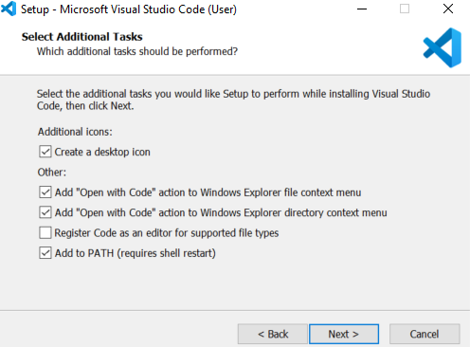

After you've done so, hit "Next" and then "Install" on the next menu. If your installation was successful, you should be able to search for "Visual Studio Code" on your machine.